**Excel Assignment – 14**

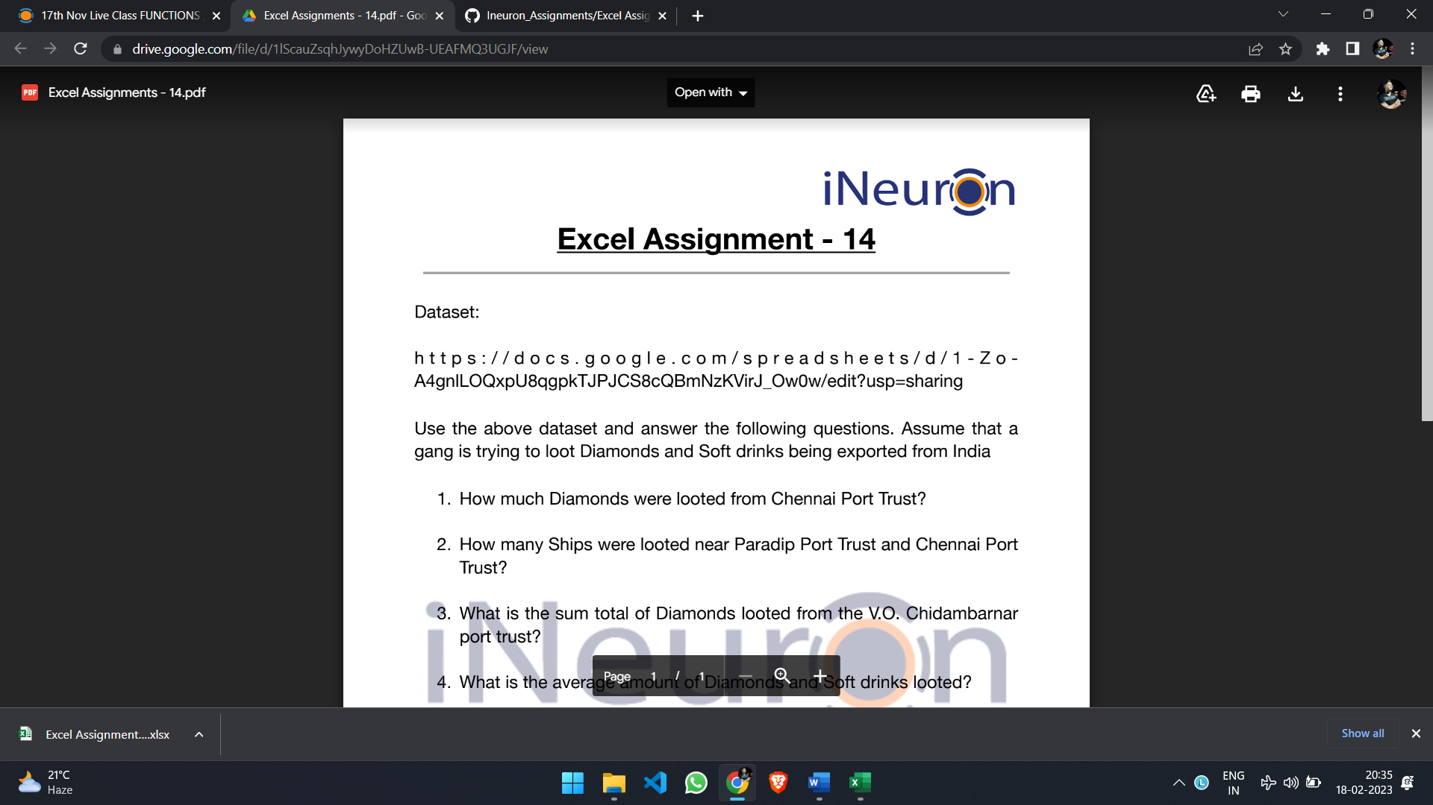

**Note: Given data has Diamonds looted (in ounces) and soft drinks looted (in gallons).**

**1. How much Diamonds were looted from Chennai Port Trust?**

**7,182** diamonds are looted from Chennai port trust.

**2. How many Ships were looted near Paradip Port Trust and Chennai Port Trust?**

**6 ships** were looted near paradip port trust and Chennai port trust.

**3. What is the sum total of Diamonds looted from the V.O. Chidambarnar port trust?**

**9,887** diamonds looted from the V.O. Chidambarnar port trust.

**4. What is the average amount of Diamonds and Soft drinks looted?**

**1254.86 and 2227.75** is the average amount of diamonds and soft drinks looted respectively.

**5. What is the ratio of soft drinks drunk to soft drinks looted?**

**0.39** is the ratio of soft drinks drunk to soft drinks looted.

